Breakups and Google Trends Search Data
Case of the Monday Blues? Interest in breaking up peaks at the end of weekend.

Photo by Elizabeth Tsung on Unsplash
Ever have a bad weekend? Did it lead to you wanting to leave your relationship? Why aren’t people sleeping at 2–4 AM Monday?
According to Google Trends data, the relative interest in breaking up peaks at 3 AM Monday in the US. As if the Monday Blues weren’t already blue enough!
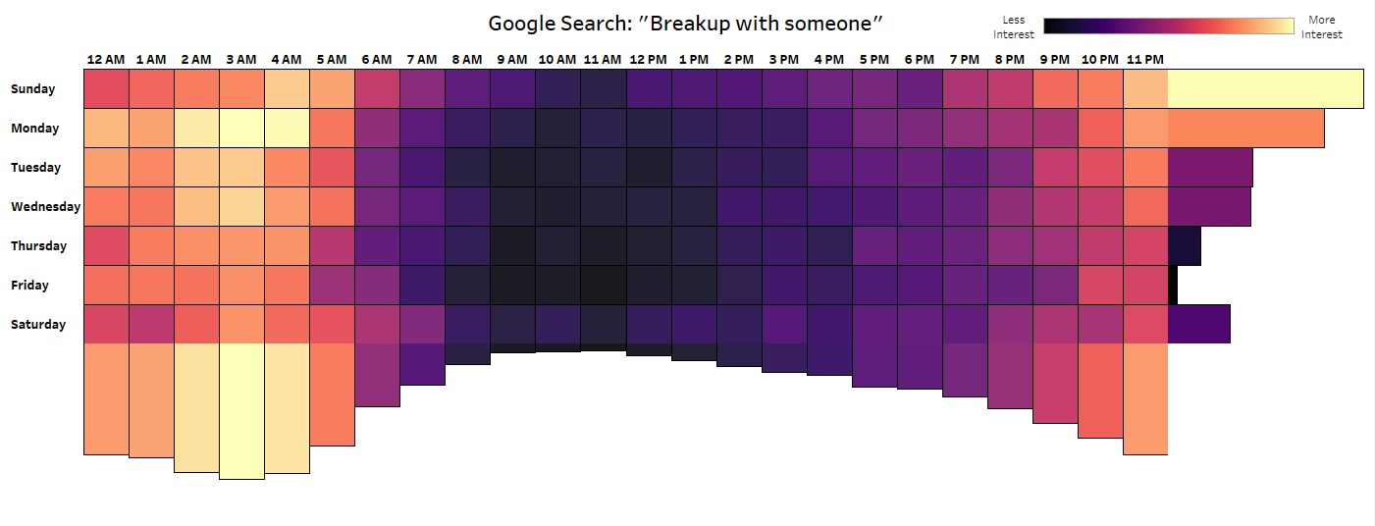
Visualization by Shelby Temple; Data Source Google Trends; Made with PyTrends and Tableau
There is a Cyclical Nature to Breakups
“What rises twice a year, once in Easter and then two weeks before Christmas, has a mini peak every Monday and then flattens out over the summer?”
David McCandless asked this question to his audience during his TED talk, The Beauty of Data Visualization.
The answer was peak break up times according to Facebook status updates.
According to 10,000 scraped Facebook statuses they found there is a clearing out for Spring Break and a second breakup peak leading up to the Winter holidays. Another pattern that emerged was a cyclical spike every Monday.
Inspired by this, I decided to use Google Trends data to explore what day and time people are searching for details on breaking up.
Google Trends
We live in a wonderful new age where we no longer have to solely rely on data sets created from surveys. We can now measure the behavior of people by watching what they do on the internet.
Google Trends is a great public tool to see what people are doing on the internet. On the Google Trends website, you can measure interest on a search topic over time or by geography. You can also compare up to five different search topics.
However, there is a key nuance to this data. It is not measuring the overall query volume. It is measuring the normalized, relative share of Google searches on a topic compared to all other searches for that time and place. For more details on how this data is collected, manipulated, and interpreted here are two useful links:
What is Google Trends data — and what does it mean?
How Trends Data is Adjusted
PyTrends
Brought to you by General Mills, (that’s right — the same people who brought you Cheerios and Lucky Charms) PyTrends is an unofficial Pseudo API package in Python that makes it easy to create magnificent new Google Trend data sets and pull them straight into a table.
“Unofficial-Sumo-API-what-now?” No need to worry, I will break this down.
Two of the most exciting ways to get data off the internet is through web scraping or web APIs. APIs have a broader definition, but for this article let’s define them as: An intended way for data to be pushed or pulled the same way you can browse the internet.
Web APIs are always the preferred method, as they are designed to push the data to you off a call. They have tons of documentation and updates on any changes.
Web scraping is essentially when there should be an API but the company doesn’t want to build it out. You pull the data right out of the html code that is sent to the web browser. This is less preferred, because if the website changes the web scraping code can easily break and you won’t know why. Web scraping is an unintended way of getting the data. Websites are not built with this in mind.
Apparently, Marissa Mayer and Google did intend to build an API for Trends in 2007 — but clearly, “coming soon” means “never” in this context.
PyTrends is unofficial. Meaning that it is not endorsed by Google. It’s a Pseudo API, meaning it behaves to us exactly like an API Python package would, however it is actually web scraping under the hood.
Here is the link, if you are interested in using or learning more about the package:
General Mills PyTrends GitHub
Check it out! With six lines of code, I am creating a Google Trend data set for all of 2017 on searches containing “How to Breakup” by day and hour.
Press enter or click to view image in full size
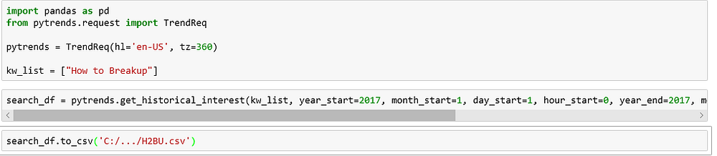
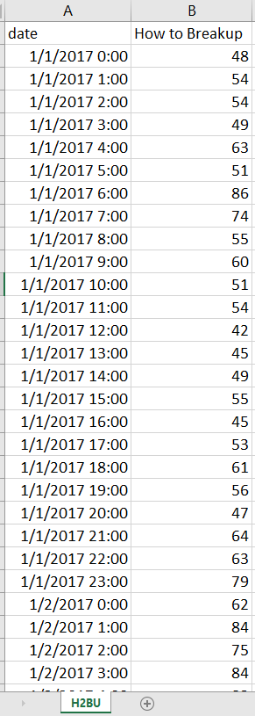
Google Trends gives you a search interest index. This is a score of 0 to 100 — with 100 being the highest search interest.
In this instance I limited the geography to the United States.
Interpreting the Results
Press enter or click to view image in full size
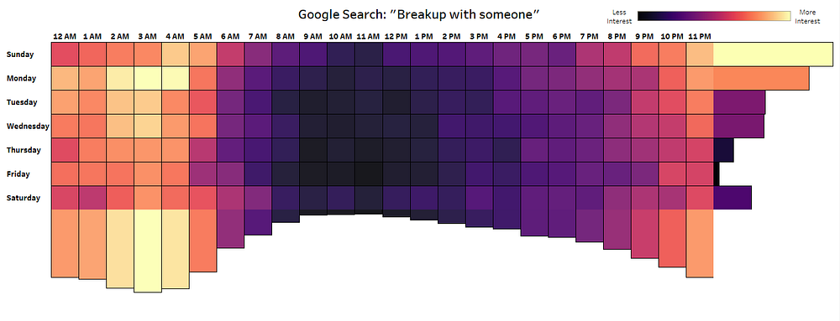
Visualization by Shelby Temple; Data Source Google Trends; Made with PyTrends and Tableau
Press enter or click to view image in full size
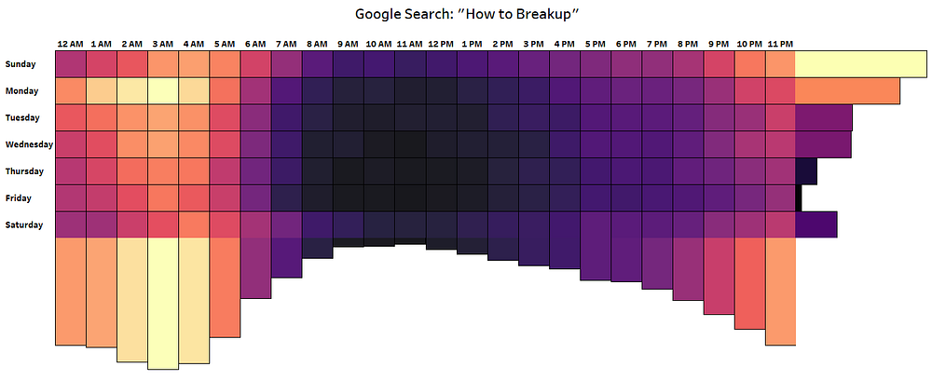
Visualization by Shelby Temple; Data Source Google Trends; Made with PyTrends and Tableau
To create these highlight tables, I took the average interest by hour and day over the entire year of 2017.
As mentioned before, Google Trends data does not show changes in volume. It measures changes in share across all searches for a given time and place. It cannot be concluded that the most searches for breaking up occurred Monday at 3 AM. A more accurate conclusion would be that if someone is searching Monday 3 AM, there is a much higher chance the search is about breaking up.
“So what about search query volume?”
Google has a different tool called Keyword Planner within Google Ads. This is a commercial product for businesses that want to run Paid Search marketing campaigns. They have an official API for Google Ads too. Unfortunately, this is not a public tool like Google Trends.
The normalization is a nuance but it is by design. The volume is often up or down based on population or the number of searches on Google. Simon Rogers, a data editor for Google wrote in this Medium article:
“ That normalization is really important: the number of people searching on Google changes constantly — in 2004 search volume was much smaller than it is today, so raw search numbers wouldn’t give you any way to compare searches then and now. By normalizing our data, we can make deeper insights: comparing different dates, different countries or different cities.”
Next time you have an interesting question or idea you want to explore. I suggest starting with Google Trends and the search data it provides. Also, remember to be extra nice to your significant other this weekend. If you are going to be a jerk — wait until 11 AM Friday.

